

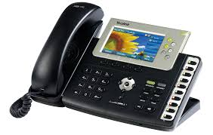

NAME : ANKIT MISHRA
CLASS : XII-A1
SCHOOL : MPVM
YEAR : 2014-15

CERTIFICATE

Certified to be the bonafide work done by
Mr. ANKIT MISHRA of class XII – A1
during the year 2014-2015
Date ______ in the subject of COMPUTER SCIENCE.

Date:
Registration No. :

Signature of Internal Examiner:

ACKNOWLEDGEMENT

I would like to express my sincere gratitude to my Computer
science mentor Mr. Shwetank Kakkar , for his vital
support, guidance and encouragement - without which this
project would not have come forth.

Student Signature:
Ankit Mishra

INDEX

TOPIC PAGE NO.
- Introduction To C++ 6-8
- Introduction to Telephone 10-11
Directory Management
- Hardware and Software 13
Requirements
- Limitations and Future 15
Scope
- Header Files and Functions 17-19
- Flow Chart 21-25
- Coding 27-65
- Input and Output 67-71
- Bibliography 72

INTRODUCTION
TO C++

INTRODUCTION TO C++

Data File Handling:
File. The information / data stored under a specific name on a storage device, is called a file.
Stream. It refers to a sequence of bytes.
Text file. It is a file that stores information in ASCII characters. In text files, each line of text is terminated with a special character known as EOL (End of Line) character or delimiter character. When this EOL character is read or written, certain internal translations take place.
Binary file. It is a file that contains information in the same format as it is held in memory. In binary files, no delimiters are used for a line and no translations occur here.

Classes For File Stream Operation:
ofstream: Stream class to write on files
ifstream: Stream class to read from files
fstream: Stream class to both read and write from/to files.

Input And Output Operation:
put() and get() function
the function put() writes a single character to the associated stream. Similarly, the function get() reads a single character form the associated stream.
example :
file.get(ch);
file.put(ch);
write() and read() function
write() and read() functions write and read blocks of binary data.
internal stream pointers that point to the reading or writing locations within a stream can be manipulated using the following member functions:
seekg() | moves get pointer(input) to a specified location
seekp() | moves put pointer (output) to a specified location
tellg() | gives the current position of the get pointer
tellp() | gives the current position of the put pointer.

File mode parameter | Meaning
ios::app | Append to end of file
ios::ate | go to end of file on opening
ios::binary | file open in binary mode
ios::in | open file for reading only
ios::out | open file for writing only
ios::nocreate | open fails if the file does not exist
ios::noreplace | open fails if the file already exist
ios::trunc | delete the contents of the file if it exist.

Linked Lists:
A linked list is a technique of creating a list with the ability to add, delete, or retrieve items. Additional operations can also be provided to a more elaborate list such as finding an item, deleting an item, etc.
The Beginning of a Linked List:
If you create an array-based list, you can start by declaring an array member variable that would hold the items and each item can be located by an index that is assigned to it when the item is added to the list. When you do this, you must provide an estimate of the maximum number of items that will be allowed in the list. Without good planning, the dimension you specify could be too high or too low but C++ doesn't allow you to declare an array without a dimension if you are not initializing the array. This means that, when you create an array-based list, you must also specify the maximum number of items that the list can hold.
A linked list is a list that can grow or shrink as the user wishes. This means that, when creating the list, you don't need to predict the maximum number of items that will be added to the list. To use this flexibility, the items must be managed through pointers. Because the list would use a member that defines its item, you can declare a member variable that is conform to the intended items.
When a list starts, it is empty or at least it must be considered like that, before any item is added to it. To specify this, you should declare a primary member variable. Although you can call it anything, it is usually called Head. This member can be made private if you don't intend to access it outside of the class. If you want clients of the class to access it, you can make it public. Although this member is declared as a pointer and it marks the beginning of the list, you should not allocate memory for it in the constructor. Its memory would be managed when it is accessed. Therefore, you can simply initialize is as NULL.
Once a list exists, the user can explorer it. One of the operations performed on items is to locate and retrieve one. To do this, you can declare a method that takes as argument as index. The method would examine the argument with regards to the number of items in the list to make sure the argument's value is in the range of current items of the list. If the number is too low or too high, the method can return null or 0. If the number is in the range, the method can return the item at that position.
One of the operations hardly performed on a list is to find one. This is because if you ask a list to locate a particular item, you must provide as much information as possible. Probably the most expedient way you can do this is to completely define an item and pass it to the list. Only if the item is found in the list would it be recognized.

INTRODUCTION TO
TELEPHONE
DIRECTORY
MANAGEMENT

TELEPHONE DIRECTORY MANAGEMENT
The telephone directory maintenance system is designed to insure a smooth allotment of telephone to the employee of a particular department and query the telephone directory whenever required.

CURRENT SYSTEM

Currently telephones are been allotted to employees at random on a first come first served basis. There is no proper tracking of who is allotted which telephone number. Any number of telephones gets allotted to the employees.

LIMITATION OF THE CURRENT SYSTEM

Because of the current system of allotment of telephone numbers to the employees at random, the same telephone number at a time gets allotted to more than one employee. There is no proper record of how many phones are allotted to each department which results in tracing of employees being difficult. There is no mechanism to find out which department a particular employee belongs to.

PROPOSED SYSTEM

The proposed system is being designed to maintain the details of employees address,pincode,telephone numbers and all their details through an application in a file. Unique record id are generated for any new employee/new company and new telephone number.

OBJECTIVES:
The system design will meet the below objectives
- Unique number generation for the new employee/new telephone allotment.
- Easy retrieval of telephone details based on employee names.
- Easy retrieval of telephone details based on the record id number.
- Deletion of the record id deletes all the information belonging to that employee.
- Employee location details can be modified whenever the employee gets transferred.

SCOPE AND BOUNDARY:

The project is designed for

- Record maintenance
  - Add records
  - Delete records

- Employee Maintenance
  - Employee addition
  - Employee modification

- Telephone Directory maintenance
  - Add telephone number
  - Enquiry by record id
  - Enquiry by Employee name
  - Enquiry by telephone no.

HARDWARE AND
SOFTWARE
REQUIREMENTS
Resource Requirement :

- Software Used : 1. Windows XP

2. Turbo C++
3. Notepad
4. MS Word

- Hardware Used: 1. Pentium III onwards

2. 128 MB RAM
3. 40GB HDD

LIMITATIONS
AND
FUTURE SCOPE

LIMITATIONS OF THE PROJECT

There are several limitations of the project. The project is subdivided into three sub-modules.

- Record maintenance system.
- Employee maintenance system.
- Telephone directory maintenance system.

There are several limitations in the module. Some of they are:
- User can store maximum of 2500 employee records.
- All the constraints are not checked properly.

Future Scope:

The future scope of this project is immense. If the small difficulties and problems can be eliminated, the software will be of great help in the real life scenario.

HEADER FILES
AND
FUNCTIONS

HEADER FILES USED:

- #include<fstream.h>: Used as header file defined in I/O library predescribed in C++ containing the iostream,fstream,ifstream files as well.

- #include<conio.h>: Used for clrscr() and getch() function for clearing the screen and printing the output just after entering records respectively.

- #include<stdio.h>: Used for remove() and rename() function (for removing and renaming a file respectively) used in file handling.

- #include<string.h>: Used for string comparison,calculating the string length.

- #include<iomanip.h>: Used for setw() function for setting of alignment in the program.

- #include<dos.h>: Used for delay() function.

FUNCTION USED:

- unsigned long get_rec_no(): Generating automatic record number for customer.

- void get_data(): Function to input data records for customers.

- void show_data(): Displaying individual customers telephone and address information.

- void add_object(): Appends new customer information into data file.

- void make_index(): Extracts the data records from file to linked list.

- void sort_name(): Arranges database acc. to name.

- void sort_recno(): Arranges database acc. to recno.

- void sort_pin(): Arranges database acc. to pin no.

- void show_object(): Functions to shows all the sorted data.

- void sort_print(): Prints the sorted record on screen.

- void del_object(): Used to delete a particular record of users choice.

- void modify_object(): Modify the customers information in database.

- void search_object(): Using this function the phoneno.dat data file is searched according to RECORD ID,NO.,NAME,PHONE NO.,PINCODE respectively and displays all the records on the screen.

- void sort_object(): Arranges the database according to recno,name , pin respectively after users choice.

- void del_all(): Used to delete all the objects created.

- void reports(): Used to generate different reports.

FLOW CHART

A:
Start
int main_choice;

A
Print -> “WELCOME TO TELEPHONE
DIRECTORY”;
Print-> " MAIN MENU ";
(Printing all the choices)
Print->" ADD A NEW RECORD ..1";
Print->" DELETE A RECORD ..2";
Print->" MODIFY A RECORD ..3";
Print->" SEARCH A RECORD ..4";
Print->" SORTED INFORMATION ..5";
Print->" REOPORTS ..6";
Print->" DELETE ALL RECORDS ..7";
Print->" EXIT ..8";
Print->"ENTER YOUR CHOICE NO.--->";
cin>>main_choice;

E

B:
A
switch(main_choice)
Case 1:
pers.add_object();
break;
Case 2:
break;
pers.del_object();
Case 3:

B
C:
B
pers.modify_object();
break;
Case 4:
break;
pers.search_object();

C
Case 5:
break;
pers.sort_object();
Case 6:
break;
D:
C
D
pers.reports();
break;
Case 7:
pers.reports();
break;
pers.del_all();
Print->ALL RECORDS DELETED";
Print->Press Any Key To Continue....;
Case 8:
Print->"YOU HAVE ENDED THE SESSION";
Print->"THANK YOU";
delay(1000);
break;
E:
FLOWCHART END

A
E
while(main_choice!=8);

CODING

CODING :
#include<fstream.h>
#include<conio.h>
#include<stdio.h>
#include<string.h>
#include<iomanip.h>
#include<dos.h>

struct node
{
unsigned long recno;
long int pin;
char name[20];
node *link; // Dynamic memory allocation
};
// Nodes are declared for sorting the phone.dat data file according
to recno,pin and name respectively.

node *first,*ptr1,*ptr2,*ptr,*temp;

//Declaration of class for maintaining the data of customer
class person
{
private:
unsigned long record_id;
char person_name[20];
char res_address[30];
long int res_pincode;
char res_phone_no1[20];
char occu_pation[10];
char company_name[20];
char off_address[20];
long int off_pincode;
char off_phone_no1[20];
public:
person()
{
record_id=0;
res_pincode=off_pincode=0;
res_phone_no1;
off_phone_no1;
}
// Generating automatic record number for customer
unsigned long get_rec_no();
// Function to input data records for customers
void get_data();
// Displaying individual customers telephone and address information
void show_data();

// Appends new customer information into data file
void add_object();
// Extracts the data records from file to linked list
void make_index();
// Arranges database acc. to name
void sort_name();
// Arranges database acc. to recno
void sort_recno();
// Arranges database acc. to pin no.
void sort_pin();
void show_object();
// Prints the sorted record on screen
void sort_print();
void del_object();
// Modify the customers information in database
void modify_object();
void search_object();
void sort_object();
void del_all();
void reports();
}pers; // Declaring global person variable
// Declaration for the get_rec_no()
unsigned long person::get_rec_no()
{
int found=0;
unsigned long rec_no,temp_recno;
struct node1
{
unsigned long recno;
node1 *link;
};
node1 *start,*ptr,*ptr1,*ptr2;
fstream infile;
infile.open("phoneno.dat",ios::in);
infile.seekg(0,ios::end);
//tellg() returns the current stream position
int n=infile.tellg();
infile.close();
if(n==0)
rec_no=1;
else
{
infile.open("phoneno.dat",ios::in);
start=ptr=new node1;
infile.seekg(0,ios::beg);
infile.read((char*)&pers,sizeof(pers));
while(!infile.eof())
{
ptr->recno=record_id;
ptr->link=new node1;
ptr=ptr->link;
infile.read((char*)&pers,sizeof(pers));
}
ptr->link=NULL;
ptr1=start;
while(ptr1->link!=NULL)
{
ptr2=ptr1->link;
while(ptr2!=NULL)
{
if(ptr2->recno<ptr1 ->recno)
{
temp_recno=ptr2->recno;
ptr2->recno=ptr1->recno;
ptr1->recno=temp_recno;
}
ptr2=ptr2->link;
}
ptr2=ptr1->link;
ptr1=ptr2;
}
ptr1=start;
while(ptr1!=NULL && found!=1)
{
ptr2=ptr1;
ptr1=ptr1->link;
if((ptr2->recno)+1!=ptr1->recno)
{
rec_no=(ptr2->recno)+1;
found=1;
}
}
if(found!=1)rec_no=(ptr2->recno)+1;
ptr=start;
while(start!=NULL)
{
start=start->link;
delete ptr;
}
}
return rec_no;
}
void person::del_all()
{
clrscr();
fstream file1,file2;
file1.open("phoneno.dat",ios::out||ios::trunc);
remove("phoneno.dat");
file2.open("temp.dat",ios::in);
file1.close();
file2.close();
rename("temp.dat","phone.dat");
}
// Function definition of get_data()
void person::get_data()
{
clrscr();
// Calling function to get record no. automatically
record_id=pers.get_rec_no();
gotoxy(5,7);
cout<<"RECORD_ID :"<<pers.record_id;
cin.get();
gotoxy(5,8);
cout<<"ENTER THE NAME--------------------->";
cin.getline(person_name,20);
cin.get();
gotoxy(5,9);
cout<<"RESIDENTIAL ADDRESS---------------->";
cin.getline(res_address,30);
cin.get();
gotoxy(5,10);
cout<<"ENTER RESIDENTIAL PINCODE---------->";
cin>>res_pincode;
cin.get();
gotoxy(5,11);
cout<<"ENTER RESIDENTIAL PHONE NO--------->";
cin.getline(res_phone_no1,20);
cin.get();
gotoxy(5,12);
cout<<"ENTER THE OCCUPATION--------------->";
cin.getline(occu_pation,10);
cin.get();
gotoxy(5,13);
cout<<"ENTER COMPANY'S NAME--------------->";
cin.getline(company_name,20);
cin.get();
gotoxy(5,14);
cout<<"ENTER COMPANY'S ADDRESS------------>";
cin.getline(off_address,20);
cin.get();
gotoxy(5,15);
cout<<"ENTER OFFICE PINCODE--------------->";
cin>>off_pincode;
cin.get();
gotoxy(5,16);
cout<<"ENTER OFFICE PHONE NO-------------->";
cin.getline(off_phone_no1,20);
cin.get();
gotoxy(5,17);
clrscr();
}
void person::show_data()
{
clrscr();
gotoxy(5,2);
cout<<"RECORD NUMBER----------------------->"<<record_id;
gotoxy(5,3);
cout<<"NAME-------------------------------->"<<person_name;
gotoxy(5,4);
cout<<"RESIDENTIAL ADDERSS----------------->"<<res_address;
gotoxy(5,5);
cout<<"RESIDENTIAL PINCODE----------------->"<<res_pincode;
gotoxy(5,6);
cout<<"RESIDENTIAL PHONE NO---------------->"<<res_phone_no1;
gotoxy(5,7);
cout<<"OCCUPATION-------------------------->"<<occu_pation;
gotoxy(5,8);
cout<<"COMPANY's NAME---------------------->"<<company_name;
gotoxy(5,9);
cout<<"COMPANY's ADDRESS------------------->"<<off_address;
gotoxy(5,10);
cout<<"OFFICE PINCODE---------------------->"<<off_pincode;
gotoxy(5,11);
cout<<"OFFICE PHONE NO--------------------->"<<off_phone_no1;
gotoxy(10,20);
getch();
}
//This function creates a master file .
void person::add_object()
{
fstream file;
char choice='y';
while(choice=='y')
{
file.open("phoneno.dat",ios::app);
get_data();
file.write((char*)&pers,sizeof(pers));
file.flush();
file.close();
clrscr();
gotoxy(10,11);
cout<<"ANY MORE RECORDS TO BE READ<<Y/N>>-------------->";
cin>>choice;
}
}
void person::del_object()
{
fstream infile,outfile;
unsigned long rec_no;
clrscr();
cout<<"ENTER THE RECORD ID.NO.TO BE DELETED--------->";
cin>>rec_no;
infile.open("phoneno.dat",ios::in);
infile.seekg(0);
outfile.open("tempno.dat",ios::app);
infile.read((char*)&pers,sizeof(pers));
while(!infile.eof())
{
if(pers.record_id!=rec_no)
outfile.write((char*)&pers,sizeof(pers));
else
{
show_data();
}
outfile.flush();
infile.read((char*)&pers,sizeof(pers));
}
gotoxy(20,20);
cout<<"Want to Delete the record(y/n)..."<<endl;
gotoxy(55,20);
char ans;
cin>>ans;
if(ans=='n'|| ans=='N')
{
return;
}
infile.close();
outfile.close();
remove("phoneno.dat");
rename("tempno.dat","phoneno.dat");
}
void person::search_object()
{
fstream infile;
int search_choice;
unsigned long rec_no;
char phno[20];
char name[20];
do
{
clrscr();
int counter=0;
gotoxy(22,7);
cout<<" SEARCH MENU ";
gotoxy(22,9);
cout<<"------------------";
gotoxy(22,11);
cout<<"RECORD ID NO. ..1";
gotoxy(22,12);
cout<<"NAME ..2";
gotoxy(22,13);
cout<<"PHONE NO. ..3";
gotoxy(22,14);
cout<<"EXIT SEARCH MENU ..4";
gotoxy(1,20);
cout<<"ENTER THE FIELD CHOICE ACCORDING TO WHICH A RECORD";
cout<<"IS TO BE SEARCHED--------->";
cin>>search_choice;
switch(search_choice)
{
case 1:clrscr();
cout<<"\n ENTER THE RECORD ID.NO. TO BE SEARCHED----->";
cin>>rec_no;
infile.open("phoneno.dat",ios::in);
infile.seekg(0,ios::beg);
infile.read((char*)&pers,sizeof(pers));
while(!infile.eof())
{
if(pers.record_id==rec_no)
{
counter++;
pers.show_data();
}
infile.read((char*)&pers,sizeof(pers));
}
infile.close();
gotoxy(20,24);
cout<<"RECORDS FOUND="<<counter;
getch();
break;
case 2:
clrscr();
cout<<"\n ENTER THE NAME TO BE SEARCHED---------->";
gets(name);
infile.open("phoneno.dat",ios::in);
infile.seekg(0,ios::beg);
infile.read((char*)&pers,sizeof(pers));
while(!infile.eof())
{
if(strcmpi(pers.person_name,name)==0)
{
counter++;
pers.show_data();
}
infile.read((char*)&pers,sizeof(pers));
}
infile.close();
gotoxy(20,24);
cout<<"RECORDS FOUND="<<counter;
getch();
break;
case 3:
clrscr();
cout<<"\nENTER THE PHONE NO.TO BE SEARCHED-------->";
cin.getline(phno,20);
cin.get();
infile.open("phoneno.dat",ios::in);
infile.seekg(0,ios::beg);
infile.read((char*)&pers,sizeof(pers));
while(!infile.eof())
{
if(pers.res_phone_no1==phno||pers.off_phone_no1==phno)
{
counter++;
pers.show_data();
}
infile.read((char*)&pers,sizeof(pers));
}
infile.close();
gotoxy(20,24);
cout<<"RECORDS FOUND="<<counter;
getch();
break;
case 4:
clrscr();
gotoxy(22,15);
cout<<"YOU HAVE ENDED THE SEARCH SESSION\n";
gotoxy(27,18);
cout<<"\tTHANK YOU!";
delay(700);
break;
}
}
while(search_choice!=4);
}
void person::modify_object()
{
fstream file;
unsigned long code;
int modify_choice;
do
{
clrscr();
gotoxy(22,7);
cout<<" MODIFY MENU ";
gotoxy(22,8);
cout<<" ---------------";
gotoxy(22,10);
cout<<"RESIDENTIAL INFORMATON ..1";
gotoxy(22,11);
cout<<"OFFICIAL INFORMATION ..2";
gotoxy(22,12);
cout<<"EXIT ..3";
gotoxy(22,13);
cout<<"SELECT THE INFORMATION TO BE CHANGED : ";
gotoxy(22,14);
cout<<"ENTER YOUR CHOICE----->";
cin>>modify_choice;
if(modify_choice!=3)
{
clrscr();
gotoxy(10,15);
cout<<"ENTER THE RECORD NO. OF THE PERSON---->";
cin>>code;
file.open("phoneno.dat",ios::in|ios::out);
file.seekg(0,ios::beg);
file.read((char*)&pers,sizeof(pers));
int n=file.tellg();
while(!file.eof())
{
if(pers.record_id==code)
{
switch(modify_choice)
{
case 1:
clrscr();
cout<<"***** The Details of "<<pers.person_name;
cin.get();
cout<<"\n\nThe old Address is : "<<pers.res_address;
cin.get();
cout<<"\nENTER NEW RESIDENTIAL ADDRESS-------->";
cin.getline(pers.res_address,30);
cin.get();
cout<<"The old Pin code is : "<<pers.res_pincode;
cout<<"\nENTER NEW PINCODE-------------------->";
cin>>pers.res_pincode;
cout<<"The old Phone No.is : "<<pers.res_phone_no1;
cout<<"\nENTER NEW RESIDENTIAL PHONE NO------->";
cin>>pers.res_phone_no1;
file.seekg(n-sizeof(pers));
file.write((char*)&pers,sizeof(pers));
file.flush();
break;
case 2:
clrscr();
cin.get();
cout<<"\nENTER THE OCCUPATION----------->";
cin.getline(pers.occu_pation,10);
cin.get();
cout<<"\nENTER NEW COMPANY'S NAME------->";
cin.getline(pers.company_name,20);
cin.get();
cout<<"\nENTER NEW OFFICE ADDRESS------->";
cin.getline(pers.off_address,20);
cin.get();
cout<<"\nENTER NEW OFFICE PIN CODE------>";
cin>>pers.off_pincode;
cin.get();
cout<<"\nENTER NEW OFFICE PHONE NO------>";
cin>>pers.off_phone_no1;
file.seekg(n-sizeof(pers));
file.write((char*)&pers,sizeof(pers));
file.flush();
break;
}
}
file.read((char*)&pers,sizeof(pers));
n=file.tellg();
}
file.close();
}
}
while(modify_choice!=3);
clrscr();
gotoxy(22,10);
cout<<"YOU ENDED MODIFY INFORMATION SESSION\n";
gotoxy(30,13);
cout<<"\tTHANK YOU";
delay(700);
}
void ex_change()
{
temp=new node;
temp->link=NULL;
temp->recno=ptr2->recno;
temp->pin=ptr2->pin;
strcpy(temp->name,ptr2->name);
ptr2->recno=ptr1->recno;
ptr2->pin=ptr1->pin;
strcpy(ptr2->name,ptr1->name);
ptr1->recno=temp->recno;
ptr1->pin=temp->pin;
strcpy(ptr1->name,temp->name);
delete temp;
}
void person::make_index()
{
fstream infile;
first=new node;
ptr=first;
infile.open("phoneno.dat",ios::in);
infile.seekg(0,ios::beg);
infile.read((char*)&pers,sizeof(pers));
while(!infile.eof())
{
ptr->recno=record_id;
ptr->pin=res_pincode;
strcpy(ptr->name,pers.person_name);
ptr->link=new node;
ptr=ptr->link;
infile.read((char*)&pers,sizeof(pers));
}
ptr->link=NULL;
infile.close();
}
void person::sort_name()
{
pers.make_index();
ptr1=first;
while(ptr1->link!=NULL)
{
ptr2=ptr1->link;
while(ptr2->link!=NULL)
{
if(strcmpi(ptr2->name,ptr1->name)<0)
ex_change();
ptr2=ptr2->link;
}
ptr2=ptr1->link;
ptr1=ptr2;
}
}
void person::sort_recno()
{
pers.make_index();
ptr1=first;
while(ptr1->link!=NULL)
{
ptr2=ptr->link;
while(ptr2!=NULL)
{
if(ptr2->recno<ptr1 ->recno)
ex_change();
ptr2=ptr2->link;
}
ptr2=ptr1->link;
ptr1=ptr2;
}
}
void person::sort_pin()
{
pers.make_index();
ptr1=first;
while(ptr1->link!=NULL)
{
ptr2=ptr1->link;
while(ptr2!=NULL)
{
if(ptr2->pin<ptr1 ->pin)
ex_change();
ptr2=ptr2->link;
}
ptr2=ptr1->link;
ptr1=ptr2;
}
}
void person::sort_print()
{
fstream infile;
ptr=first;
while(ptr!=NULL)
{
infile.open("phoneno.dat",ios::in);
infile.seekg(0,ios::beg);
infile.read((char*)&pers,sizeof(pers));
while(!infile.eof())
{
if(ptr->recno==pers.record_id)
{
pers.show_data();
infile.seekg(0,ios::end);
}
infile.read((char*)&pers,sizeof(pers));
}
infile.close();
ptr=ptr->link;
}
}
void del_index()
{
while(first!=NULL)
{
ptr=first;
first=first->link;
delete ptr;
}
}
void person::sort_object()
{
int sort_choice;
do
{
clrscr();
gotoxy(22,7);
cout<<" SORT MENU ";
gotoxy(22,8);
cout<<"-------------------";
gotoxy(22,10);
cout<<"SORTED RECORDS NOS. ..1";
gotoxy(22,11);
cout<<"SORTED NAMES ..2";
gotoxy(22,12);
cout<<"SORTED PINCODES NOS. ..3";
gotoxy(22,13);
cout<<"EXIT SORT MENU ..4";
gotoxy(22,20);
cout<<"ENTER YOUR CHOICE NO.----->";
cin>>sort_choice;
switch(sort_choice)
{
case 1:
clrscr();
pers.sort_recno();
pers.sort_print();
del_index();
delay(200);
break;
case 2:
clrscr();
pers.sort_name();
pers.sort_print();
del_index();
delay(200);
break;
case 3:
clrscr();
pers.sort_pin();
pers.sort_print();
del_index();
delay(200);
break;
case 4:
clrscr();
gotoxy(22,10);
cout<<"YOU ENDED THE SORTED SESSION\n";
gotoxy(27,13);
cout<<"\tTHANK YOU!";
delay(700);
break;
}
}
while(sort_choice!=4);
}
void person::reports()
{
fstream infile;
int report_choice;
do
{
clrscr();
gotoxy(22,7);
cout<<" REPORT MENU ";
gotoxy(22,8);
cout<<"------------------";
gotoxy(5,10);
cout<<"SORTED LIST OF NAMES WITH RESIDENCE AND OFFICE PHONE NOS. ..1";
gotoxy(5,11);
cout<<"LIST OF NAMES WITH THIER OFFICE DETAILS. ..2";
gotoxy(5,12);
cout<<"LIST OF NAMES WITH THEIR RECORD NOS.AND RESIDENTIAL ADDRESS ..3";
gotoxy(5,13);
cout<<"EXIT REPORT SESSION ..4";
gotoxy(5,14);
cout<<"ENTER YOUR CHOICE NO.------>";
cin>>report_choice;
switch(report_choice)
{
case 1:
clrscr();
{
cout<<"\n NAME RESIDENCE PHONE NO. OFFICE PHONE NO.";
cout<<"\n---------------------------------------------------------------------";
pers.sort_name();
ptr=first;
while(ptr!=NULL)
{
infile.open("phoneno.dat",ios::in);
infile.seekg(0,ios::beg);
infile.read((char*)&pers,sizeof(pers));
while(!infile.eof())
{
if(ptr->recno==pers.record_id)
{
cout<<"\n";
cout<<setiosflags(ios::left)
<<setw(28)<<pers.person_name<<setw(30)
<<pers.res_phone_no1<<setw(30)
<<pers.off_phone_no1;
infile.seekg(0,ios::end);
}
infile.read((char*)&pers,sizeof(pers));
}
infile.close();
ptr=ptr->link;
}
del_index();
gotoxy(20,20);
cout<<"PRESS ANY KEY TO CONTINUE";
getch();
break;
}
case 2:
clrscr();
infile.open("phoneno.dat",ios::in);
infile.seekg(0,ios::beg);
infile.read((char *)&pers,sizeof(pers));
while(!infile.eof())
{
gotoxy(10,5);
cout<<"NAME------------------->"<<pers.person_name;
gotoxy(10,6);
cout<<"COMPANY'S NAME--------->"<<pers.company_name;
gotoxy(10,7);
cout<<"COMPANY'S ADDRESS------>"<<pers.off_address;
gotoxy(10,8);
cout<<"OFFICE PHONE NO.------->"<<pers.off_phone_no1;
gotoxy(10,10);
cout<<"PRESS ANY KEY TO CONTINUE";
getch();
infile.read((char *)&pers,sizeof(pers));
clrscr();
}
infile.close();
break;
case 3:
clrscr();
cout<<"\nREC NO. NAME RES.ADDRESS RES PHONE NO.";
cout<<"\n-------------------------------------------------------------";
infile.open("phoneno.dat",ios::in);
infile.seekg(0,ios::beg);
infile.read((char*)&pers,sizeof(pers));
while(!infile.eof())
{
cout<<"\n";
cout<<setiosflags(ios::left)
<<setw(15)<<pers.record_id
<<setw(15)<<pers.person_name<<
setw(18)<<pers.res_address<<
setw(35)<<res_phone_no1;
cout<<setw(55)<<" ";
infile.read((char*)&pers,sizeof(pers));
}
infile.close();
gotoxy(20,40);
cout<<"\n PRESS ANY KEY TO CONTINUE";
getch();
break;
case 4:
clrscr();
gotoxy(22,10);
cout<<"YOU HAVE ENDED REPORT SESSION\n";
gotoxy(27,13);
cout<<"\tTHANK YOU";
delay(700);
break;
}
}
while(report_choice!=4);
}
void main()
{
int main_choice;
do
{
clrscr();
gotoxy(15,3);
cout<<" WELCOME TO TELEPHONE DIRECTORY ";
gotoxy(16,4);
cout<<" ================================== ";
gotoxy(19,6);
cout<<" MAIN MENU ";
gotoxy(21,7);
cout<<" ============================= ";
gotoxy(25,11);
cout<<" ADD A NEW RECORD ..1";
gotoxy(25,12);
cout<<" DELETE A RECORD ..2";
gotoxy(25,13);
cout<<" MODIFY A RECORD ..3";
gotoxy(25,14);
cout<<" SEARCH A RECORD ..4";
gotoxy(25,15);
cout<<" SORTED INFORMATION ..5";
gotoxy(25,16);
cout<<" REOPORTS ..6";
gotoxy(25,17);
cout<<" DELETE ALL RECORDS ..7";
gotoxy(25,18);
cout<<" EXIT ..8";
gotoxy(25,20);
cout<<"ENTER YOUR CHOICE NO.--------->";
cin>>main_choice;
switch(main_choice)
{
case 1:
pers.add_object();
break;
case 2:
pers.del_object();
break;
case 3:
pers.modify_object();
break;
case 4:
pers.search_object();
break;
case 5:
pers.sort_object();
break;
case 6:
pers.reports();
break;
case 7:
pers.del_all();
cout<<"\n\n\t\tALL RECORDS DELETED";
cout<<"\n\n\t\tPress Any Key To Continue.....";
getch();
break;
case 8:
clrscr();
gotoxy(22,10);
cout<<"YOU HAVE ENDED THE SESSION\n";
gotoxy(27,13);
cout<<"\tTHANK YOU";
delay(1000);
break;
}
}
while(main_choice!=8);
}

INPUT
AND
OUTPUT

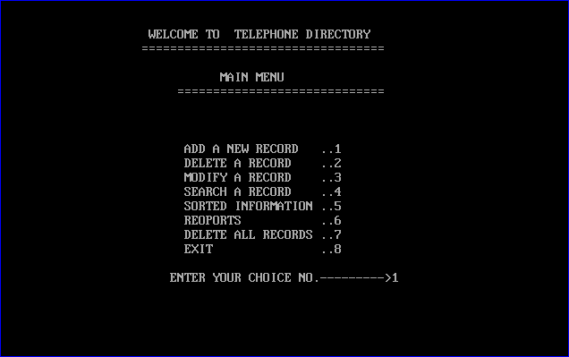

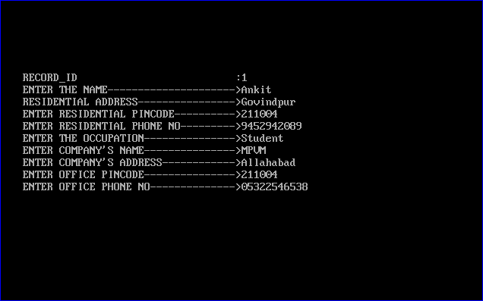
Fig.1 Main Menu

Fig.2 Fig.2 Adding Record
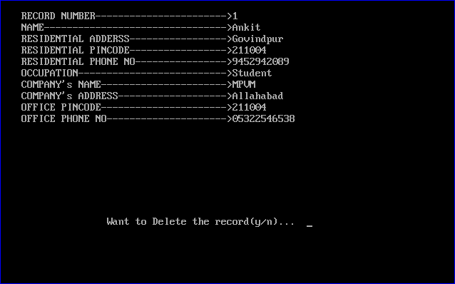

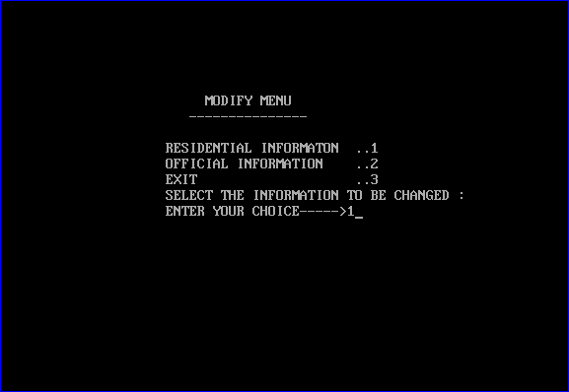
Fig.3 Deleting a record

Fig.4 Modify Menu
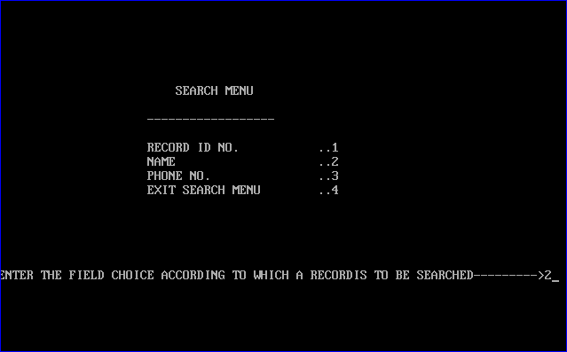

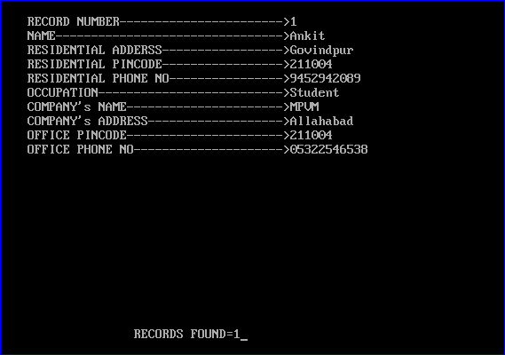
Fig.5 Search Menu

Fig.6 Fig.6 Record Found
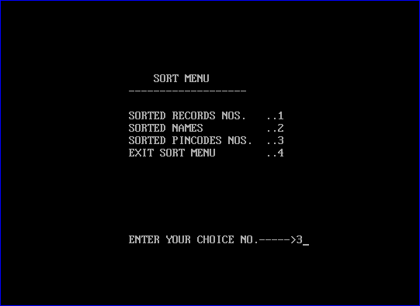
Fig.7 Fig.7 Sort Menu
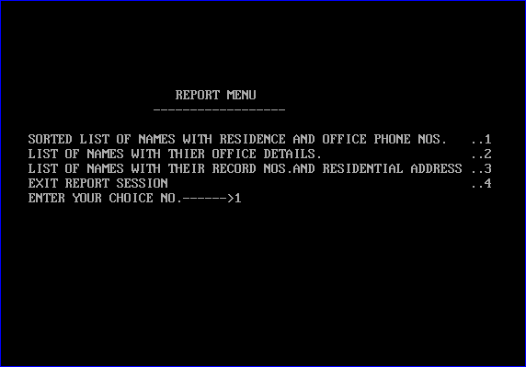
Fig.8 Report Menu
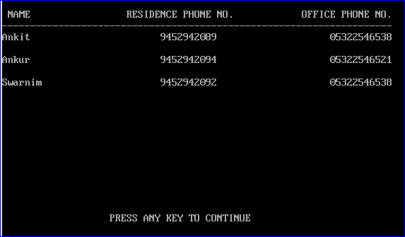

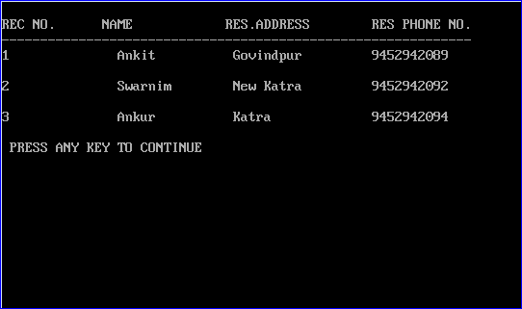
Fig.9 Report of Name, Res. Phno. And Office Phno
Fig.10 Report of Recno.,Name,Res. Add. and Res. Phno

- www.icbse.com
- www.google.com
- Class 12th C.S. book-Sumita Arora

